ONLINE GROCERY DELIVERY MANAGEMENT SYSTEM

Software Construction & Development Project Report

Submitted By:
- Mueen(FA23-BSE-028)
Course:
Software Construction & Development
Project Type:
Semester Project
Instructor:
Sania iram
Submission Date:
1 March 2026

1. Abstract
The Online Grocery Delivery Management System is a web-based application developed to facilitate online grocery shopping and home delivery services. The system allows customers to browse grocery items, add products to a cart, place orders, and make payments online.
The application also provides an administrative panel for managing products, users, orders, and delivery assignments. This system aims to enhance convenience, reduce manual workload, and improve operational efficiency for grocery stores.

Introduction

With the rapid growth of e-commerce, online grocery shopping has become a necessity. Traditional grocery shopping requires time and physical effort. The proposed system provides a digital solution that allows customers to order groceries anytime and from anywhere.
The system integrates customer management, product inventory, order processing, online payment, and delivery tracking in one centralized platform.

3. Objectives
The main objectives of this project are:
- To develop a user-friendly online grocery platform.
- To automate grocery order management.
- To provide secure online payment options.
- To manage product inventory efficiently.
- To provide real-time order tracking.
- To reduce manual errors in order processing.

4. Scope of the System
The system covers:
- Customer registration and login
- Product browsing and searching
- Shopping cart management
- Online order placement
- Payment processing
- Order tracking
- Admin product and order management
- Delivery rider management
The system does not cover physical store management or supplier chain management.

5. System Users
The system has three types of users:

5.1 Customer
- Registers and logs into the system
- Browses grocery items
- Adds items to cart
- Places orders
- Makes payments
- Tracks delivery

5.2 Admin
- Manages products (Add/Update/Delete)
- Manages users
- Views and processes orders
- Assigns delivery riders

5.3 Delivery Rider
- Views assigned orders
- Updates delivery status

6. Functional Requirements
Functional requirements define what the system should do.

FR-1: User Registration
The system shall allow new users to create accounts.

FR-2: User Login
The system shall allow registered users to log in securely.

FR-3: Product Browsing
The system shall allow users to view product categories and product details.

FR-4: Product Search
The system shall allow users to search for products by name.

FR-5: Add to Cart
The system shall allow users to add products to the shopping cart.

FR-6: Cart Management
The system shall allow users to update quantity and remove items from the cart.

FR-7: Place Order
The system shall allow users to place an order after checkout.

FR-8: Payment Processing
The system shall support online payment methods.

FR-9: Order Tracking
The system shall allow users to track order status.

FR-10: Product Management
The system shall allow admin to add, edit, or delete products.

FR-11: Order Management
The system shall allow admin to manage and process orders.

FR-12: Delivery Management
The system shall allow admin to assign delivery riders and update delivery status.

7. Non-Functional Requirements
Non-functional requirements define system quality attributes.

7.1 Performance
The system should respond within 2–3 seconds.
The system should handle multiple users simultaneously.

7.2 Security
User passwords must be encrypted.
Payment transactions must be secure.
Only authorized users can access admin panel.

7.3 Usability
The interface should be simple and user-friendly.
Navigation should be clear and easy.

7.4 Reliability
The system must ensure data consistency.
Orders should not be lost due to system failure.

7.5 Availability
The system should be available 24/7.

7.6 Scalability
The system should support increasing users and products.

7.7 Maintainability
The system should follow modular coding standards.

8. Working Methodology
The project follows Agile Development Methodology.

8.1 Requirement Gathering
Identify functional and non-functional requirements.
Prepare Software Requirement Specification (SRS).

8.2 System Design
Create UML diagrams.
Design database schema.
Define system architecture.

8.3 Development
Frontend Development (HTML, CSS, JavaScript)
Backend Development (PHP / Node.js)
Database Integration (MySQL)

8.4 Testing
Unit Testing
Integration Testing
System Testing
User Acceptance Testing

8.5 Deployment
Host system on web server.

8.6 Maintenance
Bug fixing
Performance improvement
Feature updates

9. UML Diagrams

9.1 Use Case Diagram (Description)
Actors:
- Customer
- Admin
- Delivery Rider
Use Cases:
- Register
- Login
- Browse Products
- Add to Cart
- Place Order
- Make Payment
- Track Order
- Manage Products
- Manage Orders
- Assign Delivery
- Update Delivery Status

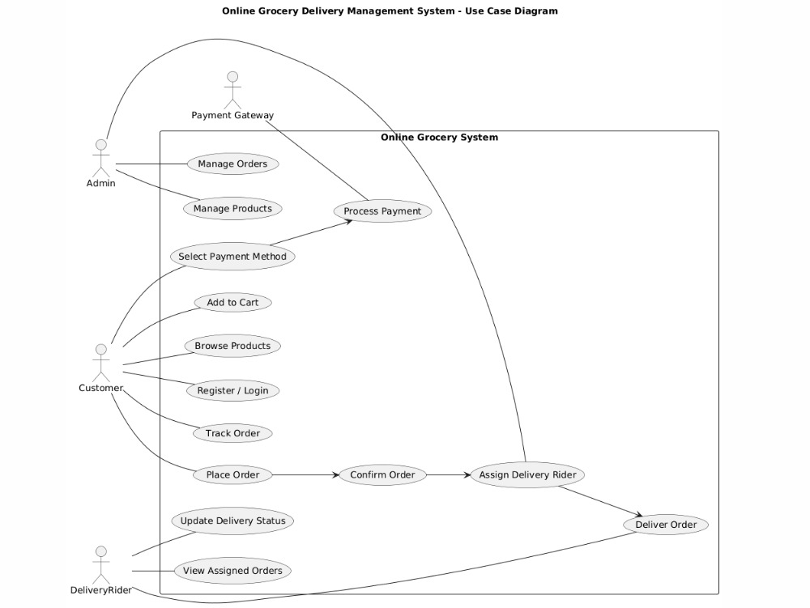

9.2 Class Diagram (Description)
Main Classes:
- User
- Product
- Cart
- Order
- Payment
- Delivery

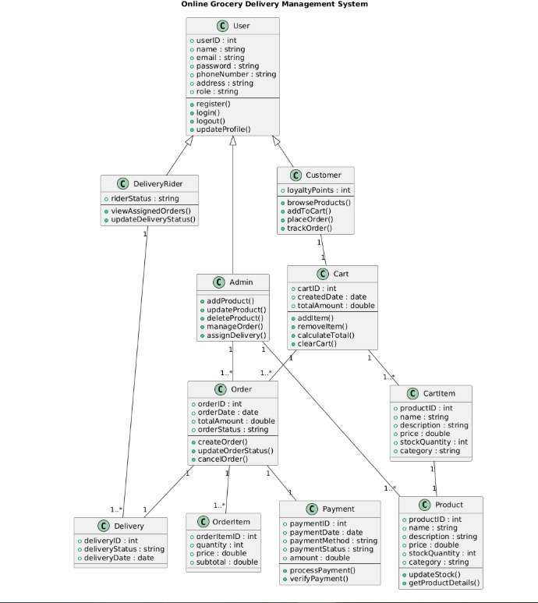

9.3 Activity Diagram (Order Process Flow)
Start
→ User Login
→ Browse Products
→ Add to Cart
→ Checkout
→ Enter Delivery Details
→ Select Payment Method
→ Confirm Order
→ Admin Processes Order
→ Assign Delivery Rider
→ Order Delivered
→ End
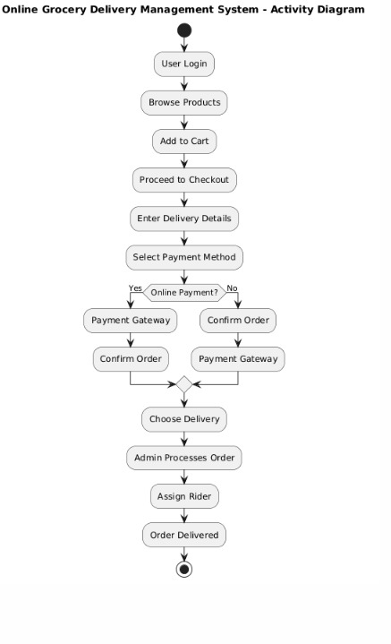

10. Conclusion
The Online Grocery Delivery Management System provides a complete digital solution for grocery shopping and delivery management. It enhances customer convenience, reduces manual workload, and improves overall business efficiency.
The system is scalable, secure, and user-friendly, making it suitable for modern grocery businesses.

